**Appendix G**

**Title**: User Evaluation Answers to Questionnaire

**Relevance**: External evaluations of the system’s search functionality were carried out by multiple individuals. These anonymised evaluations are useful in giving an idea of how the system would be received upon a full release, as well as gaining insight and opinions of the system from those not involved in the team or experienced in computing.

**Preface**

The questionnaire provided to the users can be found in Appendix J.

Statistics of results of questionnaire can be found at the bottom of the appendix.

**Name:** User B

**Date:** 1st October 2019

**Has read and signed the informed consent form:** Yes

**Has read the participant information sheet:** Yes

**General Questions 1**

1. **How visually appealing is the website?** - 4: Very appealing
2. **Does the website provide:**  - 2: Right amount of information
3. **What further information could be provided?**  - Sort/filter of costs
4. **How likely would you use the website if it were relevant to you?** - 4: Very likely

**Scenario 1**

1. **Write your exact search term below** - CHEST PAIN - TEXAS
2. **Write the name of the top search suggestions that came up when you finished typing in your search** - 313 - CHEST PAIN
3. **Did your search run as expected?** - Yes
4. **If you said Yes to the above, write hospital you selected and for which price** - The hospitals of Providence Transmountain Campus, $3431

**Scenario 2**

1. **Write your exact search term below** - HEAD
2. **Write the name of the top search suggestions, if any, that came up when you finished typing in your search** - 129 - MAJOR HEAD & NECK PROCEDURES W CC/MCC OR MAJOR DEVICE
3. **Did you manage to find a procedure to help you?** - Yes
4. **If you said Yes to the above, write hospital you selected and for which price** - Pennsylvania Hosp of the Univ of PA HEALTH SYS, $1934

**General Questions 2**

1. **How easy was it to navigate through the website?** - 4: Easy
2. **Which features did you like about our website?** - Speed, presentation/visual, maps, contact details of hospital
3. **What would you most like to see improved about this website?** - Heading - “Results”, Filter/sort function indicated
4. **Anything you disliked about the website?** - No
5. **Any further comments?** - No

**Name:** User D

**Date:** 1st October 2019

**Has read and signed the informed consent form:** Yes

**Has read the participant information sheet:** Yes

**General Questions 1**

1. **How visually appealing is the website?** - 5: Extremely appealing
2. **Does the website provide:**  - 2: Right amount of information
3. **What further information could be provided?**  - Short loading time, sleek looking website, easy to use
4. **How likely would you use the website if it were relevant to you?** - 5: Extremely likely

**Scenario 1**

1. **Write your exact search term below** - CHEST PAIN
2. **Write the name of the top search suggestions that came up when you finished typing in your search** - 313 - CHEST PAIN
3. **Did your search run as expected?** - Yes
4. **If you said Yes to the above, write hospital you selected and for which price** - The hospitals of Providence Transmountain Campus

**Scenario 2**

1. **Write your exact search term below** - CONCUSSION
2. **Write the name of the top search suggestions, if any, that came up when you finished typing in your search** - 088 CONCUSSION W MCC
3. **Did you manage to find a procedure to help you?** - No
4. **If you said Yes to the above, write hospital you selected and for which price** - No results

**General Questions 2**

1. **How easy was it to navigate through the website?** - 5: Very easy
2. **Which features did you like about our website?** - Simplicity, straight to the point and accurate prediction text
3. **What would you most like to see improved about this website?** - Fix the “no results” that I received, fix the admin login issue (researcher note: a bug occurred during this evaluation where the admin login allowed any credentials)
4. **Anything you disliked about the website?** - Nope
5. **Any further comments?** - N/A

---------------------------------------------------------------------------------------------------------------------------

**Name:** User C

**Date:** 2nd October 2019

**Has read and signed the informed consent form:** Yes

**Has read the participant information sheet:** Yes

**General Questions 1**

1. **How visually appealing is the website?** - 4: Very appealing
2. **Does the website provide:**  - 1: Too little information
3. **What further information could be provided?**  - Information of procedures should be listed. Private hospitals could be provided
4. **How likely would you use the website if it were relevant to you?** - Very likely

**Scenario 1**

1. **Write your exact search term below** - Myocardial Infarction
2. **Write the name of the top search suggestions, if any, that came up when you finished typing in your search** - 282 - ACUTE MYOCARDIAL INFARCTION, DISCHARGED ALIVE W/O CC/MCC
3. **Did your search run as expected?** - Yes
4. **If you said Yes to the above, write hospital you selected and for which price** - TEXAS HEALTH PRESBYTERIAN HOSPITAL DALLAS - $5409

**Scenario 2**

1. **Write your exact search term below** - Subarachnoid Haemorrhage
2. **Write the name of the top search suggestions that came up when you finished typing in your search** - Nothing
3. **Did you manage to find a procedure to help you?** - No
4. **If you said Yes to the above, write hospital you selected and for which price** -

**General Questions 2**

1. **How easy was it to navigate through the website?** - 5: Very easy
2. **Which features did you like about our website?** - Very easy to search. Find pricing for both insured and uninsured helpful. Can localise to state and by distance
3. **What would you most like to see improved about this website?** - Could have listed pricing high to low. Aesthetic procedures. Private hospitals. Reviewing of surgeons (see BAAPS)
4. **Anything you disliked about the website?** - Too simplistic for a health professional. More info on procedures
5. **Any further comments?** - Further procedures needed (plastics, dermatology, etc.)

---------------------------------------------------------------------------------------------------------------------------

**Name:** User H

**Date:** 2nd October 2019

**Has read and signed the informed consent form:** Yes

**Has read the participant information sheet:** Yes

**General Questions 1**

1. **How visually appealing is the website?** - 4: Very appealing
2. **Does the website provide:**  - 2: Right amount of information
3. **What further information could be provided?**  - None
4. **How likely would you use the website if it were relevant to you?** - 4: Very likely

**Scenario 1**

1. **Write your exact search term below** - Vagina, cervix & vulva procedures
2. **Write the name of the top search suggestions that came up when you finished typing in your search** - the correct one
3. **Did your search run as expected?** - No
4. **If you said Yes to the above, write hospital you selected and for which price** -

**Scenario 2**

1. **Write your exact search term below** - Faint, head
2. **Write the name of the top search suggestions, if any, that came up when you finished typing in your search** - Major head & neck procedures
3. **Did you manage to find a procedure to help you?** - Yes
4. **If you said Yes to the above, write hospital you selected and for which price** - Baylor University, $4762

**General Questions 2**

1. **How easy was it to navigate through the website?** - 5: Very easy
2. **Which features did you like about our website?** - Very nice frontend
3. **What would you most like to see improved about this website?** - Loading times
4. **Anything you disliked about the website?** - No
5. **Any further comments?** - No

---------------------------------------------------------------------------------------------------------------------------

**Name:** User A

**Date:** 2nd October 2019

**Has read and signed the informed consent form:** Yes

**Has read the participant information sheet:** Yes

**General Questions 1**

1. **How visually appealing is the website?** - 4: Very appealing
2. **Does the website provide:**  - 2: Right amount of information
3. **What further information could be provided?**  - None
4. **How likely would you use the website if it were relevant to you?** - 3: Somewhat likely

**Scenario 1**

1. **Write your exact search term below** - chest
2. **Write the name of the top search suggestions that came up when you finished typing in your search** - 313 - CHEST PAIN
3. **Did your search run as expected?** - Yes
4. **If you said Yes to the above, write hospital you selected and for which price** - LAKE POINTE MEDICAL CENTER, $4648

**Scenario 2**

1. **Write your exact search term below** - conc
2. **Write the name of the top search suggestions, if any, that came up when you finished typing in your search** - 088 - CONCUSSION W MCC
3. **Did you manage to find a procedure to help you?** - No
4. **If you said Yes to the above, write hospital you selected and for which price** -

**General Questions 2**

1. **How easy was it to navigate through the website?** - 5: Very easy
2. **Which features did you like about our website?** - Loading wheel
3. **What would you most like to see improved about this website?** - Search bar should move away when results come up
4. **Anything you disliked about the website?** - No
5. **Any further comments?** - No

---------------------------------------------------------------------------------------------------------------------------

**Name:** User F

**Date:** 2nd October 2019

**Has read and signed the informed consent form:** Yes

**Has read the participant information sheet:** Yes

**General Questions 1**

1. **How visually appealing is the website?** - 4: Very appealing
2. **Does the website provide:**  - 2: Right amount of information
3. **What further information could be provided?**  - Phone numbers
4. **How likely would you use the website if it were relevant to you?** - 5: Extremely likely

**Scenario 1**

1. **Write your exact search term below** - Chest pain - any state
2. **Write the name of the top search suggestions that came up when you finished typing in your search** - 163 - MAJOR CHEST PROCEDURES W MCC
3. **Did your search run as expected?** - Yes
4. **If you said Yes to the above, write hospital you selected and for which price** - Physicians Regional Medical Center

**Scenario 2**

1. **Write your exact search term below** - Head hurt, then concussion when that didn’t work
2. **Write the name of the top search suggestions, if any, that came up when you finished typing in your search** - Concussion followed by weird abbreviations
3. **Did you manage to find a procedure to help you?** - No
4. **If you said Yes to the above, write hospital you selected and for which price** -

**General Questions 2**

1. **How easy was it to navigate through the website?** - 5: Very easy
2. **Which features did you like about our website?** - Clean UI, fast search
3. **What would you most like to see improved about this website?** - Some search terms, remove confusing elements
4. **Anything you disliked about the website?** - As above
5. **Any further comments?** - Well done

---------------------------------------------------------------------------------------------------------------------------

**Name:** User E

**Date:** 2nd October 2019

**Has read and signed the informed consent form:** Yes

**Has read the participant information sheet:** Yes

**General Questions 1**

1. **How visually appealing is the website?** - 4: Very appealing
2. **Does the website provide:**  - 2: Right amount of information
3. **What further information could be provided?**  - When you search a description of the procedure so that the lay person understands what procedure they are selecting
4. **How likely would you use the website if it were relevant to you?** -4: Very likely

**Scenario 1**

1. **Write your exact search term below** - chest pain
2. **Write the name of the top search suggestions that came up when you finished typing in your search** - 313 - CHEST PAIN
3. **Did your search run as expected?** - Yes
4. **If you said Yes to the above, write hospital you selected and for which price** - Lake Pointe Medical Center, $4781

**Scenario 2**

1. **Write your exact search term below** - Concussion
2. **Write the name of the top search suggestions, if any, that came up when you finished typing in your search** - Concussion
3. **Did you manage to find a procedure to help you?** - No
4. **If you said Yes to the above, write hospital you selected and for which price** -

**General Questions 2**

1. **How easy was it to navigate through the website?** - 4: Easy
2. **Which features did you like about our website?** - Well designed, nice colours
3. **What would you most like to see improved about this website?** - Bit buggy, map stopped working, price needs to be displayed on the search terms
4. **Anything you disliked about the website?** - No
5. **Any further comments?** -

---------------------------------------------------------------------------------------------------------------------------

**Name:** User G

**Date:** 2nd October 2019

**Has read and signed the informed consent form:** Yes

**Has read the participant information sheet:** Yes

**General Questions 1**

1. **How visually appealing is the website?** - 4: Very appealing
2. **Does the website provide:**  - 2: Right amount of information
3. **What further information could be provided?**  - Information on the type of procedure, when searching for a procedure, many results come up, information on the differences between them would be helpful
4. **How likely would you use the website if it were relevant to you?** - 3: Somewhat likely

**Scenario 1**

1. **Write your exact search term below** - Chest pain
2. **Write the name of the top search suggestions that came up when you finished typing in your search** - 313 - CHEST PAIN
3. **Did your search run as expected?** - Yes
4. **If you said Yes to the above, write hospital you selected and for which price** - Lake Pointe Medical Centre, $4648

**Scenario 2**

1. **Write your exact search term below** - Head injury
2. **Write the name of the top search suggestions, if any, that came up when you finished typing in your search** - None, later tried term “concussion” which yielded results
3. **Did you manage to find a procedure to help you?** - No
4. **If you said Yes to the above, write hospital you selected and for which price** -

**General Questions 2**

1. **How easy was it to navigate through the website?** - 5: Very easy
2. **Which features did you like about our website?** - Simple layout, easy to use
3. **What would you most like to see improved about this website?** - After searching, remind the user of the search term. Provide results for more vague search terms, i.e. for scenario of the term “head injury”
4. **Anything you disliked about the website?** -
5. **Any further comments?** -

---------------------------------------------------------------------------------------------------------------------------

**Statistics**

**Questionnaire Multiple Choice Scores (amount of information was rated out of 3, rest out of 5)**

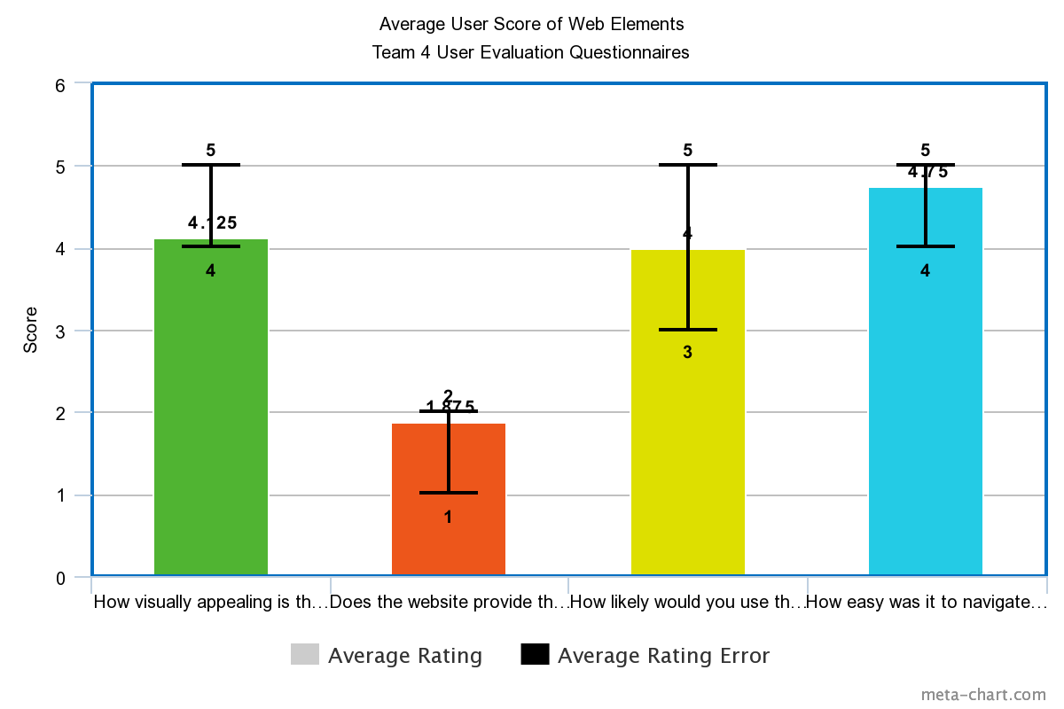

**Word Clouds for Question Answers**

**Which features did you like about our website?**

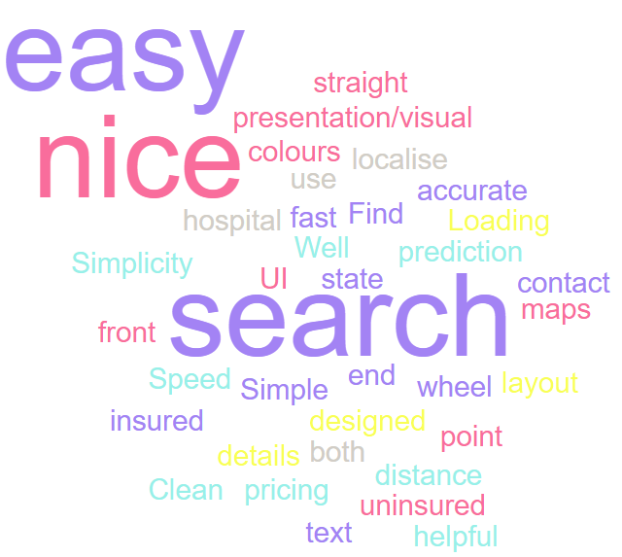

**What would you most like to see improved about this website?**

